Proposal for IT1507
Web Applications Development

Module Group : BI1703

Name (Admin No.) : Terris Tan (172737L)

Website Overview

- Define the purpose
- Identify the Audience

This website aims to reason people into knowing why Mc Donald's favourite classics are unhealthy and bad for consumption if taken at a regular basis and how to choose a healthier food option in Mc Donald's. It is aimed to be a general knowledge site for the general public but most importantly to young adults and parents. Content is curated from the Internet. All content (textual / images / multimedia) are properly referenced.

Website Design

- Plan the Content

Webpages in the website:
- Homepage
  - Overview
  - Classic Food Menu
    - Classical Burgers
      - Cheeseburger
      - Big Mac
      - Mc Spicy
    - Sides
      - French Fries
    - Deserts
      - Apple Pie
      - Oreo McFlurry
      - Vanilla Cone
      - ChocoCone
    - Beverages
      - Coca-Cola
      - Ice Lemon Tea
    - Breakfast
      - Big Breakfast
      - Sausage McMuffin with Egg
      - Breakfast Wraps
      - Hashbrown
      - Ice Milo

  - Healthier choices
    - Filet-O-Fish
    - Corn Cup
    - Apple Slices
    - Jasmine Green Tea
    - 100% Pure Orange Juice
    - Low-Fat Hi-Calcium Milk
    - Hotcakes
  - Contact Us
    - Our location
    - Feedback Form
    - Customer Feedbacks

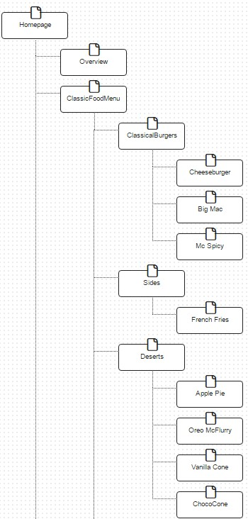
- Plan the Structure

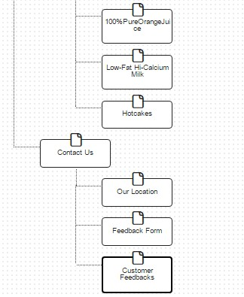
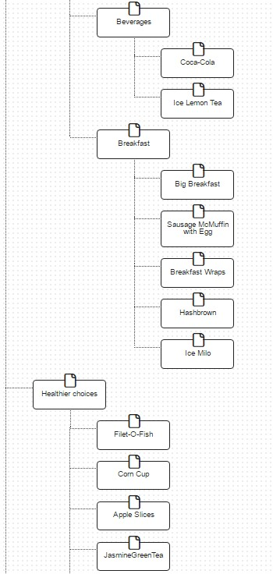

- Plan the Web Pages
- Homepage
  - Animation (Done by self)
  - Information (Short introduction)
- Overview
  - Pictures
  - Video/Animation
  - Information (About self)
- Classic Food Menu
  - No content. Just in menu.
- Classical Burger – Cheeseburger
  - Table (Information)
  - Information
  - Video/Animation/Images
- Classical Burgers – Big Mac
  - Table (Information)
  - Information
  - Video/Animation/Images
- Classical Burgers – Mc Spicy
  - Table (Information)
  - Information
  - Video/Animation/Images
- Sides – French Fries
  - Table (Information)
  - Information
  - Video/Animation/Images
- Deserts – Apple Pie
  - Table (Information)
  - Information
  - Video/Animation/Images
- Deserts – Oreo McFlurry
  - Table (Information)
  - Information
  - Video/Animation/Images
- Deserts – Vanilla Cone
  - Table (Information)
  - Information
  - Video/Animation/Images
- Deserts – ChocoCone
  - Table (Information)
  - Information
  - Video/Animation/Images
- Beverages – Coca-Cola
  - Table (Information)
  - Information
  - Video/Animation/Images
- Beverages – Ice Lemon Tea
  - Table (Information)
  - Information
  - Video/Animation/Images
- Breakfast – Big Breakfast
  - Table (Information)
  - Information
  - Video/Animation/Images
- Breakfast – Sausage McMuffin with Egg
  - Table (Information)
  - Information
  - Video/Animation/Images
- Breakfast – Breakfast Wraps
  - Table (Information)
  - Information
  - Video/Animation/Images
- Breakfast – Hashbrown
  - Table (Information)
  - Information
  - Video/Animation/Images
- Breakfast – Ice Milo
  - Table (Information)
  - Information
  - Video/Animation/Images
- Healthier Choices – Filet-O-Fish
  - Table(Informatiom)
  - Information
  - Video/Animation/Images
- Healthier Choices – Corn Cup
  - Table (Information)
  - Information
  - Video/Animation/Images
- Healthier Choices – Apple Slices
  - Table (Information)
  - Information
  - Video/Animation/Images

- Healthier Choices – Jasmine Green Tea
  - Table (Information)
  - Information
  - Video/Animation/Images
- Healthier Choices – 100% Pure Orange Juice
  - Table (Information)
  - Information
  - Video/Animation/Images
- Healthier Choices – Low-fat Hi-Calcium Milk
  - Table (Information)
  - Information
  - Video/Animation/Images
- Healthier Choices – Hotcakes
  - Table (Information)
  - Information
  - Video/Animation/Images
- Contact Us – Our location
  - Information
- Contact Us – Feedback Form
  - Form (1 form)
- Contact Us – Customer Feedbacks
  - Table (A section where good questions/feedbacks will be posted for others to see)

- Plan the Navigation

- Homepage

Banner/Title

Navigation
Menu
Animation

Short introduction
Contact info/
Navigation to Contact Us

- Overview

Banner/Title

Navigation
Menu
About Us
Video/Animation

Pictures

- Classic Food Menu – Classical Burgers -> Cheese Burgers/Big Mac/Mc Spicy
(For each)
Banner/Title

Navigation
Menu
Video/
Animation/
Images
Table

Information

- Classic Food Menu – Sides -> French Fries

Banner/Title

Navigation
Menu
Video/
Animation/
Images
Table

Information

- Classic Food Menu – Deserts -> Apple Pie/Oreo McFlurry/Vanilla Cone/ChocoCone (For each)
Banner/Title

Navigation
Menu
Video/
Animation/
Images
Table

Information

- Classic Food Menu – Beverages -> Coca-Cola/Ice Lemon Tea (For each)
Banner/Title

Table
Video/
Animation/
Images
Navigation Menu

Information

- Classical Food Menu – Breakfast -> Big Breakfast/Sausage McMuffin with Egg/
Breakfast Wraps/Hashbrown/Ice Milo (For each)
Banner/Title

Table
Video/
Animation/
Images
Navigation
Menu

Information

- Healthier Choices -> Corn Cup/Apple Slices/Jasmine Green Tea/100% Pure
Orange Juice/Low-Fat Hi-Calcium Milk/Hotcakes (For each)
Banner/Title

Navigation
Menu
Table
Video/
Animation/
Images

Information

- Contact Us – Our location
Banner/Title

Navigation
Menu
Information

- Contact Us – Feedback Form
Banner/Title

Navigation
Menu
Form
Navigation to Customer Feedbacks

- Contact Us – Customer Feedbacks
Banner/Title
Navigation
Menu
Table (Customer Feedbacks)
Navigation to Feedback Form

